Project Porpoise
game design document
gam150s13-d
spring 2013

Aftermath Games

jordan Krissi
Producer - Input, AI
joe lubertazzi
Technical Director - Core Engine Systems
joe sopko
Lead Designer – Gameplay, Audio
michael Yagi
Product Manager - Physics

Table of Contents
- High Concept 2
- Summary 2
- Game Flow 2-3
- Game Mechanics 3-4
- Game Characters 4
- Game Resources 5
- Game Environment 5
- Game Controls 6
- Visual Design 6
- Audio Design 7
- Behavior Design 7
- Physics Design 7-8
- Multiplayer Design 8

I. High Concept
- A 2D top-down, competitive multiplayer deathmatch game where players are bound together and must battle in an arena.

II. Summary
- Combatants fight within a single screen arena starting with a bond connecting them. If the bond is stretched to its limit, it will tighten and launch the players towards one another. Using their attack, players can dispatch one another in a single swipe to score points. First one to 10 points wins the match! Players can force an engagement by either charging toward opponents with a forward dash or by dashing backwards to tighten the bond to its limit, at which point both players will be hurled towards one another along the path of the bond.

III. Game Flow
- Game experience is intended to be fast-paced and hectic. Engaging gameplay is constantly occurring as there is no reliable way to run and it only takes one hit to die. A series of game screens are shown below to illustrate the game flow of a single life.

III. Game Flow (cont.)
- Individual lives will typically last from 5 to 20 seconds. Matches end when one player gets to 10 points, usually lasting somewhere between 2 and 5 minutes. Players can rematch each other as many times as they would like.

IV. Game Mechanics
- The bond is the defining mechanic of the game. When the bond is loose it is a light blue, however as it tightens it becomes more red until it reaches its limit and flings the players towards one another. The bond mechanic allows for casual players to experience an organized chaos and more hardcore players to enjoy a solid combination of action and strategic spacing.
- The two primary methods of movement are walking and dashing:
  - Walking is omnidirectional and determines the direction the player is facing. The red eye within the players
  - Dashing is restricted to either the direction the player is facing or the opposite direction the player is facing depending on whether the forward or backward dash is utilized. A dash will end after a short period of time, how long will be determined during play testing.
- A graph illustrating the relative velocity curves for walking and dashing is shown below.

IV. Game Mechanics (cont.)
- Player interaction primarily occurs through the attack mechanic. If any part of one player’s attack comes in contact with the other player, the other player will dissipate and 1 point will be awarded for the hit. Both players will then be repositioned to their starting points and gameplay will resume. If players’ attacks come into contact with one another the players will be sent backwards several character lengths.
- The first player to 10 points wins the round.
- Players start in neutral idle state, from which they can choose to move, attack, or dash.
  - If moving players can either sword or dash.
  - If attacking players must wait a short time for their attack to end to return to idle.
  - If dashing players can either attack or dash again.
- Possible actions during different game states are illustrated in diagram form below.
V. Game Characters
- Players and A.I. will take the form of a hydrogen atom with a single electron. Due to hydrogen atoms innate desire to have two electrons in their outer shell, the atoms fight to the death to claim their opponent’s electron. An atomic bond pulls them together until one atom floats away the victor.
VI. Game Resources
- There are currently no game resources in order to maintain a manageable scope. If production moves quickly and smoothly, there are stretch considerations for power ups such as quicker movement or a shield.
VII. Game Environment
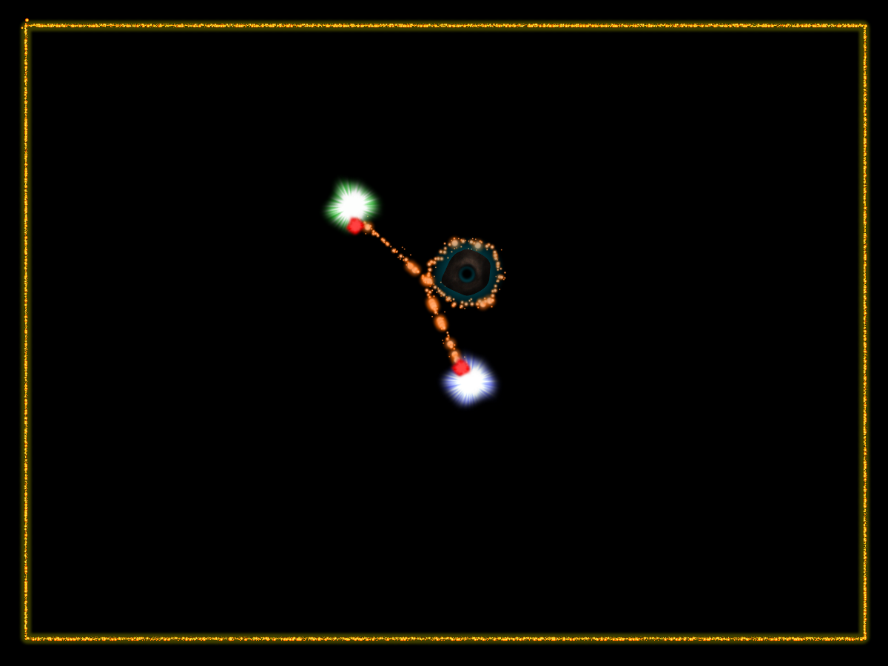
- Environments will consist of single screen, convex shaped arenas such as hexagons, circles, rectangles, triangles, and squares. Static obstacles will be present in some arenas but not others, and can be used in various ways. For example, the bond connecting the players has the capability to be wrapped around small objects, further straining it and possibly causing it to tighten, resulting in the players being thrown along the path of the bond.
- The players will be confined to the boundaries of the arena, defined by a visible solid line.
VIII. Game Controls
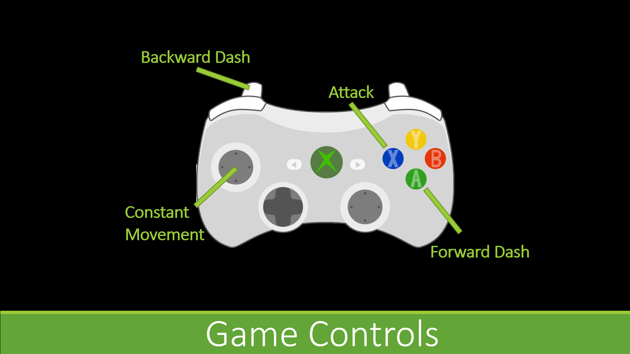
- The game is recommended to be played with an X-Box controller although there will be alternative control schemes for players that only have a keyboard accessible to them. A graphic below illustrates the button inputs and their corresponding mechanics.

IX. Visual Design
- The visual aesthetic is arcade-like and abstract. It is 2D and the camera is top-down and in a fixed position. Most of the art assets will be done through particle systems. Many different types of effects, mostly utilizing particles, will occur to stimulate player feedback.
- Since the arena is fixed, the camera does not move. There will, however, be a “freeze frame” every time a player scores a point, at which point the camera will temporarily zoom in, and the game will pause momentarily, accentuating the blow by the victorious player.

X. Audio Design
- The majority of the soundscape will consist of sound effects. Every single action that occurs in the game will have an accompanying sound effect. For example, the bond will make a loud snapping noise, the players’ attacks will have a smooth whooshing noise, clashing attacks, dashing, constant movement, landing a hit on another player.
- Although the soundscape will comprise of almost entirely sound effects, there will be a light electronic background track that is nonintrusive. It will have a steady beat, but will not be in the foreground, as the sound effects are vital to player experience.
- In addition to a sound effect for every action, there will be several background music tracks, all with a similar sounding electronic beat.

XI. Behavior Design
- The two main functions of the computer player will consist of moving and attacking.
- Movement will be broken down into regular directional movement and dashing forwards or backwards. Generally, due to the cool down period of the dash, the computer player will use basic movement to maneuver around the arena. The dash will be saved for split second decisions such as dodging, charging to attack, and snapping the cord.
- Attacks are used for both offense and defense. If the computer player is about to get hit, it can use the sword swipe to block and be deflected to safety.
- The computer will not be too complex as there are only two main states. There will be a variable level of AI difficulty, ranging from very easy to nearly impossible.

XII. Physics Design
- Physics will be comprised of collision detection, pseudo rope physics, and elastic collision.
- Collision detection will be mainly circle-to-circle collision, but line and box collision detection will also be available.
- Because of the complicated nature of true rope physics, the game will resort to pseudo rope physics. This will be done by breaking down the rope into numerous line segments that connect one end to the other giving the impression of one uniform rope.

XII. Physics Design (cont.)
- When being launched by the bond, players will be hurled by an impulse directed at the path of the bond.

- Some form of elastic collision will be implanted to handle the distances that the players are launched when attacks clash and cancel out.

XIII. Multiplayer Design
- The game is primarily designed to be played by two players as a local multiplayer game. However it will still be playable with a single player fighting against an A.I. opponent.

